COVID-19 Universal Emergency

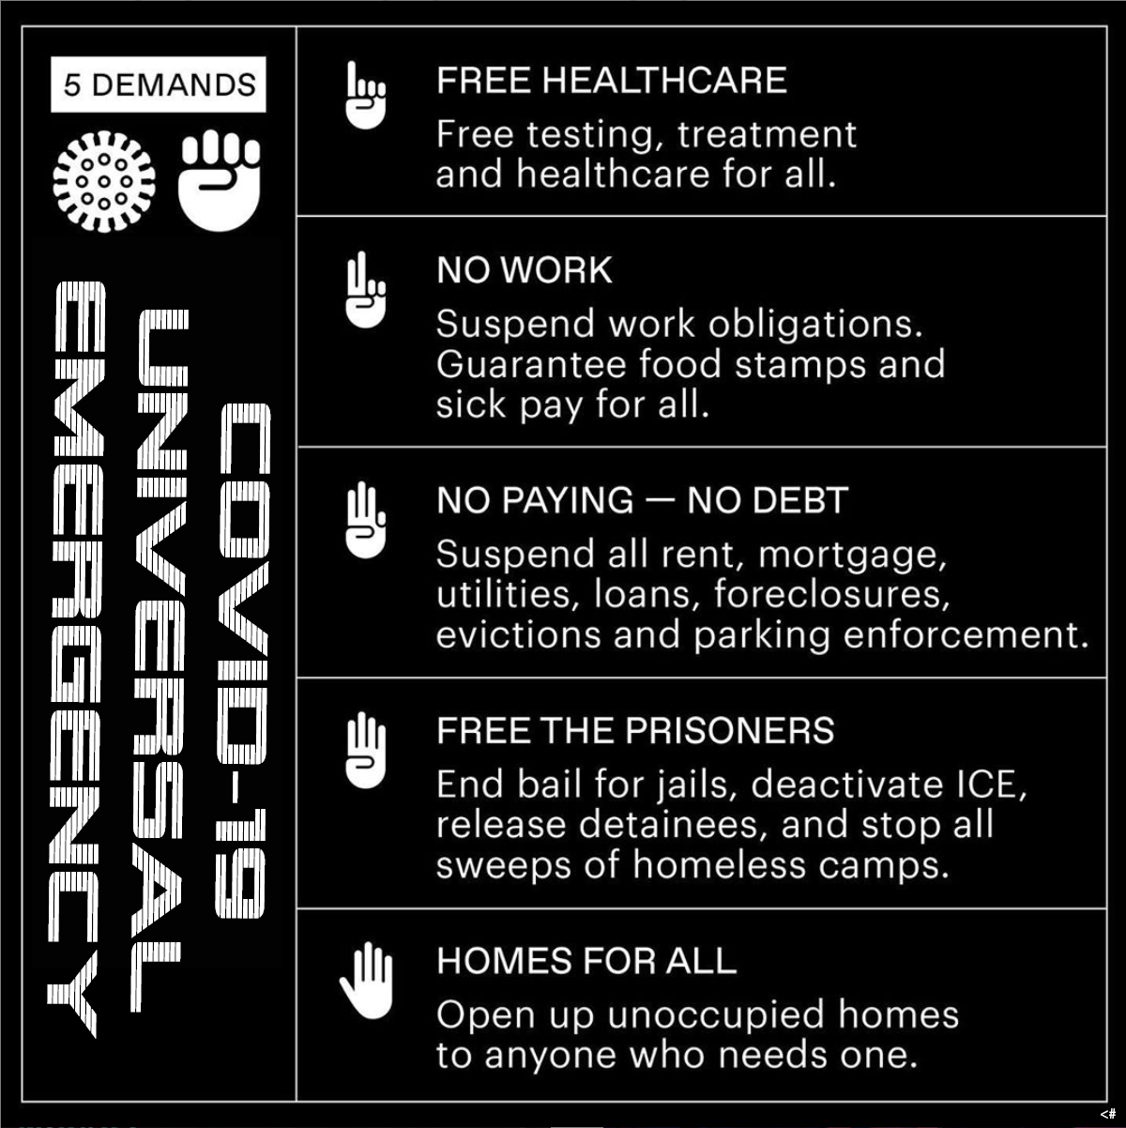

*“We need to reclaim our humanity, together, right now, once and for all in the history of our species! Universalist Emergency across the planet is being applied. The USA has the means and ability to show the planet how we begin the new world - we do not need another war against each other to come together against full economic collapse or even extinction.”* - 185668232

Addendum:

* We need low-income housing employees's homes and potential property debt frozen.
* We need all shifts that were cancelled, documented by the agencies that employed us for those shifts and compensated for by state property tax (lease rental/land ownership) to be paused.
* We need the amount of money we made last year via taxes, to verify our supplemental income that should bypass our landlords directly into the state real estate taxes, exempting the landlords any responsibility to cover the individual since the state and federal government needs to write all of this off for the individuals.
* Anyone [without a home](https://sayyestohss.org/take-action/?utm_campaign=p-progorg&utm_content=3&utm_source=fb&utm_medium=soc&fbclid=IwAR3ZNfJS6RRB6C38VAwe5WEI1xOeeTGFnATJMx96KZI_BCtW97DhqeKMsrs) should be offered their own safe space via uninhabited spaces on the real estate market. People with property they are not personally living in and/or trying to sell, will be reimbursed later through paperwork. Those in the system to receive benefits will be offered 1st choice for their struggle to actualize equanimity for all, very quickly.
* All utilities and communication services will remain on without collecting debt for the entirety of COVID19 and/or extend further depending on sustainability circumstances.
* Anyone outside of immediate tax documents will be offered FULL social services IMMEDIATELY and followed up with documents where they will gin the process of investigating all bank accounts, employers, cost of living and the bare minimum to simply stay at home with food stamps, electricity, water, medical and communications grid.
* We need everyone to remain quarantined at the cost of the entertainment industry and in turn, we need a buffer zone until work is back up and going, if not anytime soon, this would be a great opportunity to test out UNIVERSAL HOUSING INCOME.
* Anyone able to still work without infection, will be further incentivized with inflated tax returns.
* Some stocks such as the communication sector and medical industry, are safe places to begin federal fund lending to multiply and thus be delegated back out to the people who need help most.
* All private prisons should release their inmates into their own homes as stated above with full benefits and online education with a starter-computer.
* ICE will be entirely disbanded because the only people who have jobs right now are the immigrants and we applaud them, all over the world, for making their dreams come true as human beings on the planet Earth - we do not need to see other suffering because it directly affects the psychology of our species well being.
* World militaries need to deactivate and reposition their defenses against the virus rather than each other. They, plus private companies, are the only ones who have the technology to explore the cause of this sickness, which scientists believe is in the northern ice caps that are melting down through into uninhabitable Russia, into China, where it is being spread. It is believed to be an ancient virus that perhaps also helped to wipe out the planet millions of years ago before everything froze over, probably from the same meteoroid that carried the virus and blocked out the sun with debris. Now that the climate is warming up, the ice that kept the virus frozen, is melting, releasing the illness into the world that has no immunity to a brand new virus. These same world militaries can be reused to build more renewable post-industrial infrastructures. (Forward thinking: The incentive for these military workers would be credit to have anything they desire on the planet to make their lives better since everyone will already have their own homes, food and means to maintain those. The word ‘military’ could retain a new definition in years to come, something similar to ‘post-industrial.’)

The following entities have been reached out to rebuild a new collaborative sustainable infrastructure together:

*Mayor Bill de Blasio Senator Kirsten Gillibrand Senator Charles Schumer Donald J. Trump President of the United States U.S. House of Representatives U.S. Senate United Nations United States Supreme Court Bernie Sanders Brookfield Asset Management Johnson & Johnson NextEra Nestlé CoreCivic JPMorgan Chase GEO Group U.S. Department of State U.S. Department Of Housing*

As our world is changing, the most creative thinkers on the planet are immediately influenced by this planetary crisis. It is now a revelation what humanity must do to handle the tidal wave of events to come and forever in the future. 10 years of this should help the whole species on every continent will have its’ first chance to design the world we all wanted as children and for our children. Allowing for these horrific world conditions to resonate psychologically, is horrific but with compassion through our very tight communication-information infrastructures of 2020, the economic relationships we have now, do not require us to repeat the history of the 1930's. I personally work in the corporate trade-show ballroom audio-video industry in Manhattan, NY, USA and all my part time scheduled work has been cancelled due to COVID19 terror. However, many people in my field have helped me draft this petition. We are the solution to this confusion: **COVID-19 UNIVERSAL EMERGENCY** [NOW] !

Prepared by [185668232inc.](http://185668232.org)  
Image edited by <#.

COVID19 Survival Resources

<https://www.cdc.gov/coronavirus/2019-ncov/index.html>

<https://www.ilostmygig.com>  
  
<https://www.change.org/p/donald-j-trump-federal-aid-package-for-events-industry?fbclid=IwAR1H1pXfGqNjSafPt1QFWcNu_crIFQY4sEo7kVIDFW4pvAs2dLz3p1uFBg0>

<https://sayyestohss.org/take-action/?utm_campaign=p-progorg&utm_content=5&utm_source=fb&utm_medium=soc&fbclid=IwAR009Xy_nnGmQMkG2Dj9SeYwwJPsPmcFc5egtHX3F4fyZ77GzK7Z65oRGWA>

<https://www.nytimes.com/2020/03/06/arts/covid-19-movies-theaters-concerts-museums.html>

<https://sign.moveon.org/petitions/covid-19-universalist-emergency>

<https://www.ipetitions.com/petition/covid-19-universalist-emergency?fbclid=IwAR19Lut1wSiGWeEBcMhrVeqnJAYbk4bpisU_B9jBBmv8kbZ8d5ZmUUbmojQ>